Abstract

Team Members :-

Name | Department | Year | University
Rahul Deo Jha | IT | 2nd | KIIT
Kumar Shivam | IT | 2nd | KIIT
Preetesh  K Chaudhary | IT | 2nd | KIIT
Yash Dwivedi | IT | 2nd | KIIT
Tanmay Raj | IT | 2nd | KIIT
Team id –: 25KTGSANP513266

SAND ROVER

The abstract aims to summarize the research conducted from various online sources. While our actual design will be inspired by the concepts presented here, it may not include all the features described. There may be slight differences in the final design, as this abstract serves as a representation of our research findings.
Table of Contents

CONTENT | PAGE NO.
Introduction | 1
Table of content | 2
Design of the Sand Rover | 3-4
Momentum System | 5-6
Aerodynamics and Physical concept | 7-14
Electrical Components | 15-17
Circuit Diagram | 18-19
Photos of rover(reference) | 20
Rover Components with budget | 21
Thank you note | 22

Design of the Sand Rover:

The Sand Rover is meticulously designed with a focus on durability, stability, and efficiency, making it ideal for sandy and loose soil terrains. The design integrates various engineering principles to enhance performance and adaptability for diverse applications.
- Chassis and Frame
The chassis of the Sand Rover forms the foundation of the vehicle, providing structural integrity while ensuring optimal durability and stability in challenging environments. The chassis is designed as a rectangular structure, which is ideal for housing various components like the drivetrain, power supply, and payload in a balanced and organized manner.
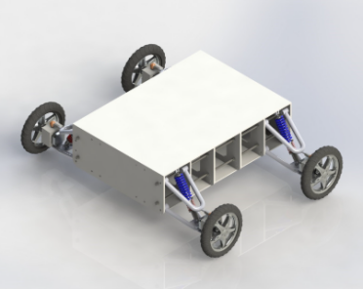
Materials Selection:
The primary material used in the chassis construction is a high-strength aluminum alloy or a composite material with a high strength-to-weight ratio. These materials are chosen for their ability to withstand mechanical stresses and environmental factors, such as extreme temperatures and moisture, without adding excessive weight to the vehicle. Aluminum, for example, is lightweight, corrosion-resistant, and strong enough to absorb shocks without failure, making it suitable for off-road applications where durability is critical. The use of composite materials could further reduce weight while offering increased resistance to wear and tear
Structural Integrity and Flexibility:

To ensure durability, the chassis is reinforced at key stress points, such as where the suspension system mounts, and where the wheels interact with the ground. This reinforcement allows the rover to absorb and dissipate shocks effectively when navigating rough or uneven terrain.
At the same time, the chassis incorporates enough flexibility to withstand minor impacts without cracking or warping. This is particularly important in environments where the rover may encounter hidden obstacles or sudden bumps that could otherwise compromise its structural integrity.

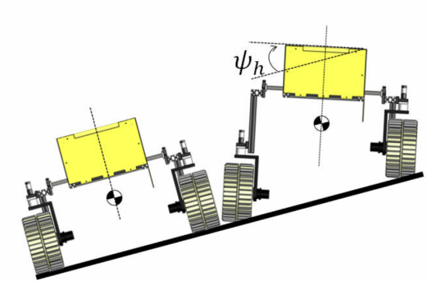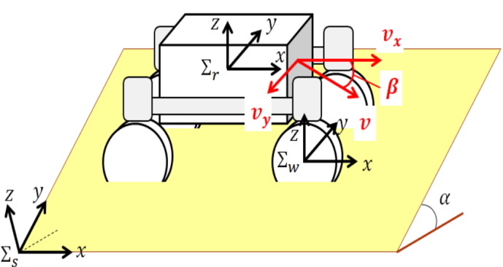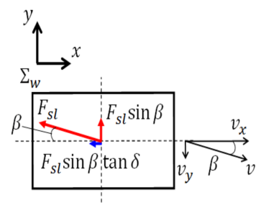

Aerodynamics and Airflow:

The open-frame chassis not only contributes to strength and durability but also improves airflow to critical components such as the battery and motors. In harsh environments like deserts, where temperatures can be extremely high, maintaining proper cooling for the electronic systems is essential. The open design allows air to circulate freely around the components, preventing overheating and ensuring consistent performance over long durations.

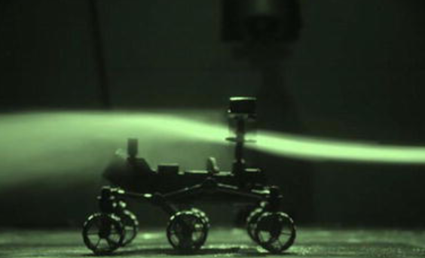

The aerodynamics of a sand rover, designed to traverse sandy and uneven terrains, focus on different challenges compared to rovers operating in more rigid environments. The primary goal for sand rovers is to reduce drag while maintaining stability on soft surfaces like sand dunes and loose soil. To achieve this, the rover’s design is often characterized by a wider body, large wheels, or tracks, which help distribute the weight more evenly and prevent the rover from sinking into the sand. These features also minimize the rover's exposure to wind resistance, ensuring smoother navigation through the sand.

Mounting and Customization:

Finally, the chassis is designed with customization in mind. It features multiple mounting points for modular accessories such as extra storage, scientific equipment, sensors, or communication devices. This flexibility makes the Sand Rover adaptable for a wide range of applications, from exploration to search-and-rescue missions. The design also ensures that each component is securely fastened, minimizing the risk of damage during operation in challenging terrains.

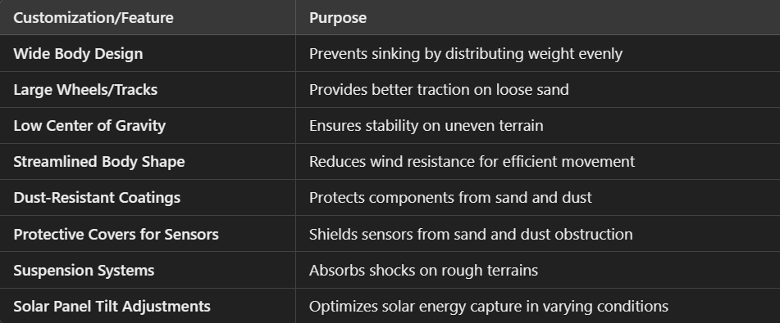

Momentum System

- Four-Motor Drive System:

Utilizing four independent motors for each wheel offers several advantages:

- Enhanced Maneuverability: With individual control over each wheel, the robot can execute complex movements, including 360-degree turns, by varying the speed and direction of each motor.

- Improved Stability: This configuration allows for precise control over the robot's orientation, enhancing stability during turns and when navigating uneven terrain.

- Increased Payload Capacity: Distributing the driving force across four wheels can lead to better weight distribution, potentially increasing the robot's payload capacity.

This approach is commonly used in robotics to achieve high levels of control and stability.

2. Transmitter and Receiver System:

The use of transmitters and receivers enables wireless communication between the robot and its control system. This setup allows for remote operation, real-time data transmission, and the ability to control the robot from a distance, which is essential for tasks where manual control is necessary or when operating in hazardous environments.

- Reverse Thrust Implementation:

Reverse thrust involves redirecting the robot's propulsion to generate a force opposite to its direction of motion. In robotics, this can be achieved using mechanisms like propellers or fans. The benefits include:

- Enhanced Control: Reverse thrust can provide additional control over the robot's movement, especially in aerial or wall-climbing robots.

- Increased Stability: By adjusting the thrust direction, the robot can stabilize itself during maneuvers or when encountering obstacles.

For example, in wall-climbing robots, reverse thrust can be used to generate an adsorption force, allowing the robot to adhere to surfaces and navigate vertical or inverted environments.
5
- Left-Right (Steering) System Design

The steering system is crucial for directing the robot's movement. In a four-wheel independent drive system, each wheel can be steered individually, offering:

- Precise Directional Control: Independent steering allows for accurate adjustments to the robot's path, enabling complex maneuvers such as turning in place or following curved trajectories.

- Adaptability to Various Terrains: The robot can adjust its wheel orientations to navigate different surfaces and obstacles effectively.

- This design is particularly beneficial in applications requiring high manoeuvrability .
A. Steering System:

The steering system comprises the mechanisms and controls that adjust the orientation of each wheel. In your design, this likely involves:
- Actuators: Devices that physically adjust the wheel angles based on control inputs.
- Control Algorithms: Software that processes input commands and determines the appropriate wheel orientations to achieve the desired movement.
A well-designed steering system ensures that the robot can respond accurately to control inputs, maintaining stability and precision in its movements.

B. Differential Motor Control:

Differential motor control involves varying the speed and direction of each motor to control the robot's movement. In a four-wheel independent drive system, this means:
- Speed Variation: Adjusting the speed of each motor to control the robot's velocity and direction.
- Direction Control: Changing the direction of individual motors to enable turning, rotation, and other maneuvers.
This method allows for precise control over the robot's movement, enabling complex behaviors such as spinning in place, following curved paths, and navigating obstacles.

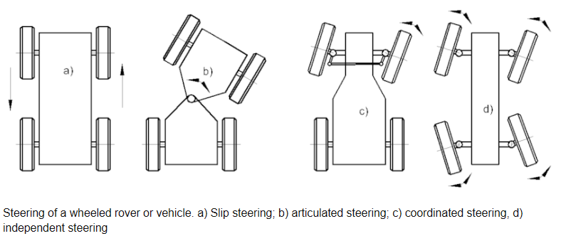

3. Aerodynamics and Physical Concepts

In addition to the fundamental principles of aerodynamics, friction, motion, and stability, there are other critical factors involved in optimizing the performance of a sand rover. These additional considerations include advanced topics like energy efficiency, terrain interaction, and dynamic system behavior, which further influence the rover’s design and functionality in real-world conditions, particularly in harsh and variable environments like sand.

1. Aerodynamics:
While the role of aerodynamics is less significant for a sand rover compared to high-speed vehicles, minimizing air resistance still plays an important role in optimizing energy efficiency, especially at higher speeds.

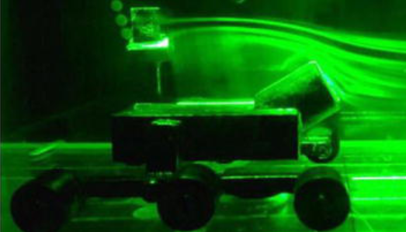

Drag Force and Design Considerations:

- Drag Coefficient Variation: The drag coefficient CdC_d varies significantly with the shape of the rover. A more streamlined shape reduces drag, but the design for a sand rover also needs to balance aerodynamics with stability on uneven terrain. The body design should ideally reduce drag without compromising the rover’s ability to handle obstacles.

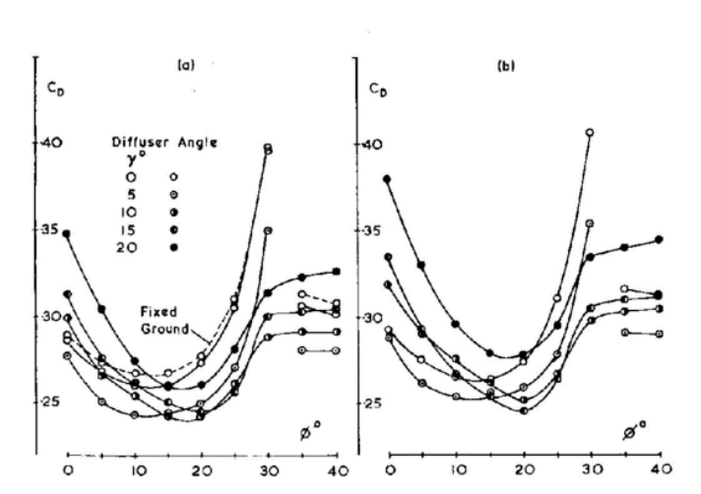

(A) STATIONARY (B) MOVING

- Surface Texture: The surface finish of the rover impacts drags. A smoother surface reduces friction with air molecules and therefore reduces drag. However, in sand environments, excessive smoothness may reduce traction during turns or while climbing dunes.

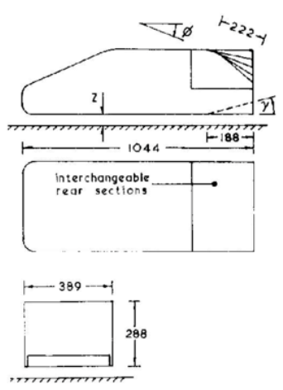

Influence of Wind and Crosswinds:

- Crosswind Impact: While crosswinds typically have a minimal effect on low-speed vehicles, gusts of wind or a consistent wind direction could alter the rover's stability when driving across open areas like deserts. The rover's design should accommodate possible crosswinds that could destabilize it.

- Wind Resistance on High-Speed Movements: In cases where the rover must traverse expansive open areas at higher speeds (for example, during long-distance travel), optimizing aerodynamics becomes more critical. A streamlined body shape helps reduce wind resistance and improves energy consumption during such movements.

2. Friction and Traction:
Friction is one of the most important forces affecting the rover’s movement, especially when navigating over sand, which presents significant challenges like uneven terrain and shifting surfaces.
Sand-Specific Friction:

- High Friction on Loose Sand: In loose sand, the friction coefficient increases due to the granular nature of the surface, but the vehicle can sink if the wheels are not large or designed for this type of terrain. The wheels must have enough surface area to prevent excessive sinking into the sand. As the sand compacts, the friction changes, and the rover’s ability to move forward efficiently also changes.
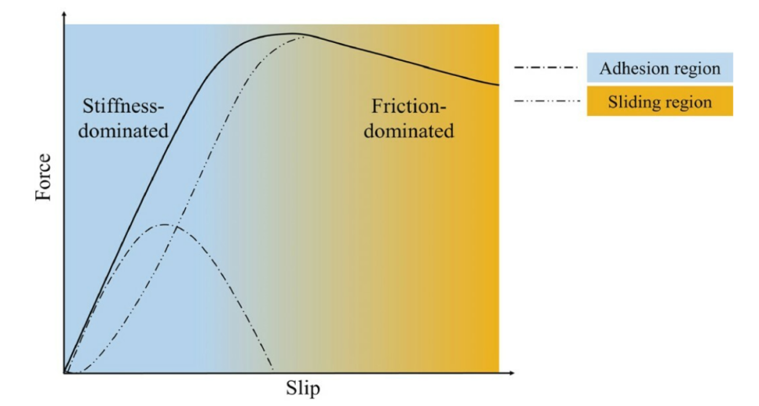

- Shear Strength of Sand: The interaction between the rover's wheels and the sand also depends on the shear strength of the sand. When the shear strength is low (loose, soft sand), the rover’s wheels can easily dig in and get stuck. On harder-packed sand, the rover can move more easily. This variability must be taken into account when designing the rover for different types of sand terrain.

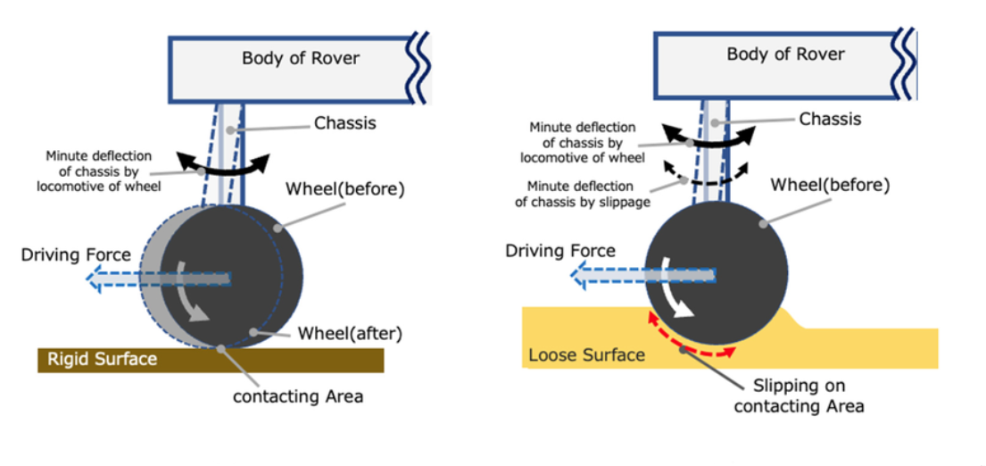

Traction Control:

- Wheel Slip and Control: Too much wheel slip reduces the rover’s ability to move forward efficiently. For better traction, the rover may incorporate slip control systems that adjust the torque provided to each wheel dynamically, especially when navigating steep inclines or shifting sand. This ensures the wheels are always making effective contact with the sand, minimizing energy loss.

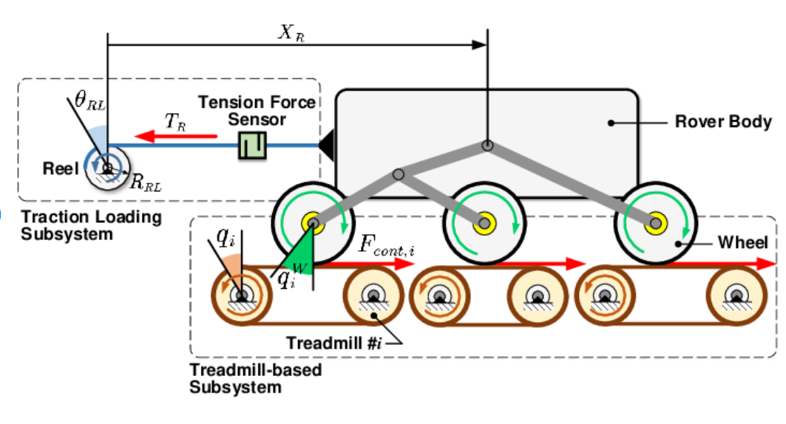

- Wheel Spinning and Sand Performance: At low speeds, excessive wheel spinning can lead to sinking. The speed and torque of the motors should be finely tuned for the type of sand the rover is operating on. At higher speeds, too little wheel slip can be inefficient as it leads to underuse of available power.

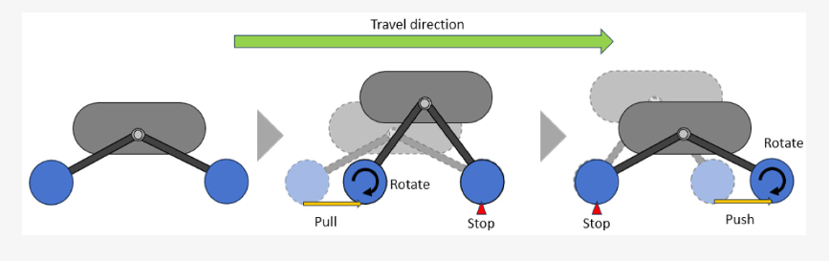

3. Motion and Kinematics:

The rover's motion, which is the result of forces applied by the motors and wheel system, follows basic principles of classical mechanics. By understanding kinematics and dynamics, the rover's response to applied forces can be predicted and optimized.

Linear and Rotational Motion Combined:

- Differential Drive System: The differential drive system (using two sets of motors for left and right wheels) enables the rover to perform sharp turns by varying the speed of the left and right motors. This allows for 360-degree turns, providing high maneuverability.

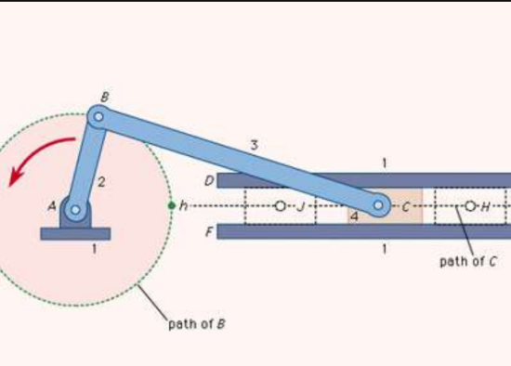

- Forward and Backward Motion: The rover moves forward when both left and right motors move in the same direction and backward when the motors rotate in the opposite direction. The speed of the rover is directly proportional to the power supplied to the motors. In sand, this needs to be balanced carefully with the traction limits of the wheels.

Velocity and Acceleration in Sand:

- Acceleration Response on Soft Surfaces: On soft, loose sand, the rover will experience higher resistance, requiring more force to achieve the same acceleration as it would on a harder surface. The relationship between force and acceleration (Newton's second law) is key here.

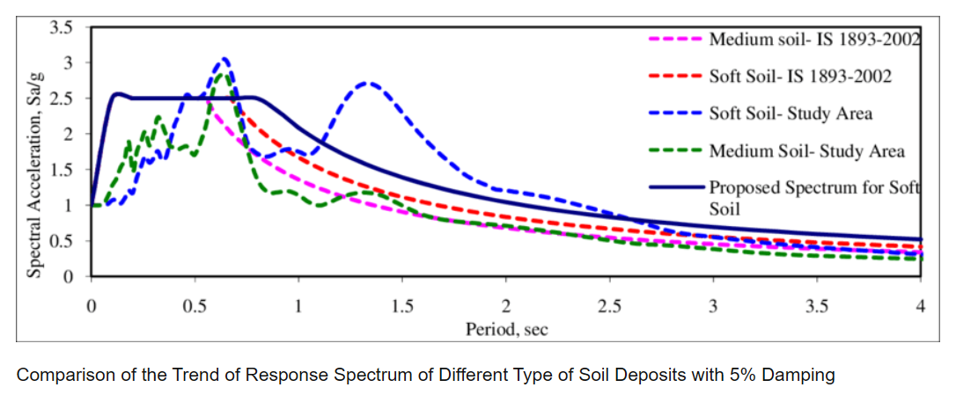

- Centripetal Force in Turns: When the rover turns, centripetal force pulls the rover toward the center of the turning circle. In the context of sand, this force must be managed to prevent the rover from flipping or losing traction during sharp turns. If the friction is too low, this can cause the rover to lose grip and slide out of control.

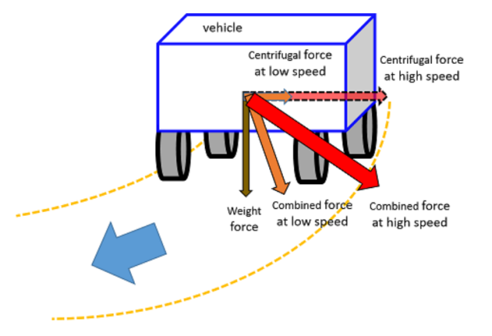

4. Weight Distribution and Stability:

The weight distribution of the rover influences its overall stability, especially in uneven terrain like sand dunes, where uneven forces act on the rover during movement.

Centre of Gravity (CG) and Stability:

- Low Centre of Gravity: A lower center of gravity helps reduce the likelihood of tipping over, which is particularly crucial when moving up or down sand dunes or when making sharp turns. By placing the heaviest components, like the battery, closer to the base of the rover, stability can be improved.

- Load Distribution: Uneven load distribution (e.g., placing the battery at one end) can cause the rover to lean or tip, reducing stability. The chassis should be designed to ensure balanced load distribution across the four wheels, preventing instability during movement

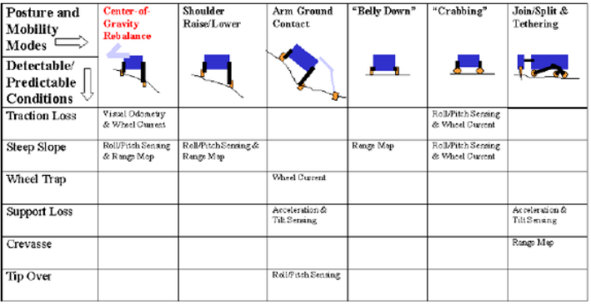

Wheelbase and Track Width:

- Wheelbase: A longer wheelbase (distance between the front and rear wheels) improves stability, reducing the risk of flipping when climbing hills or navigating obstacles. However, too long of a wheelbase could reduce maneuverability, which is a key trade-off in rover design.

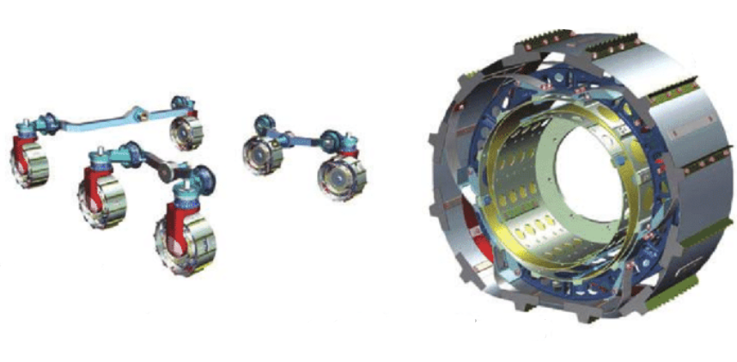

- Track Width: A wider track width helps increase the rover's stability by spreading the weight over a larger area and reducing the chances of the rover tipping sideways. This is especially important when the rover is traversing soft or shifting sand, which can cause uneven forces on the wheels.

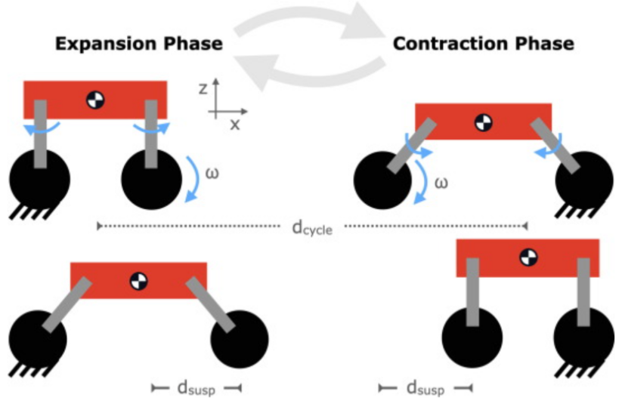

Tilt and Slope Navigation:

- Navigating Slopes: When the rover is moving up or down a slope, the forces acting on it change. Gravity increases the difficulty of climbing and, if the slope is too steep, the rover may lose traction. The rover’s design should include features like low-sag suspension or flexible wheel mounts to prevent the vehicle from becoming stuck in deep sand.

- Roll and Pitch Control: For sand dunes, managing the pitch (forward and backward tilt) and roll (side-to-side tilt) of the rover ensures that the wheels maintain sufficient contact with the sand to maintain traction.

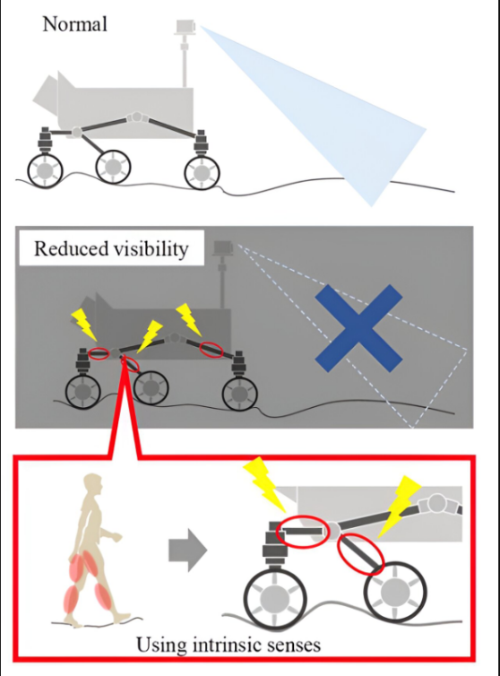

5. Energy Consumption and Efficiency:
Energy management is crucial, particularly in off-grid operations where the rover relies on its battery for power.

Motor Efficiency:

- High Torque DC Motors: The use of high torque DC motors is essential for sand rovers, especially when dealing with the high resistance of sand. These motors offer a balance between power and efficiency, ensuring the rover can move without draining the battery too quickly.

- Efficiency Mapping: By using efficient control algorithms, such as pulse-width modulation (PWM), the motors can be made to operate within their optimal power range, minimizing energy waste and improving battery life.

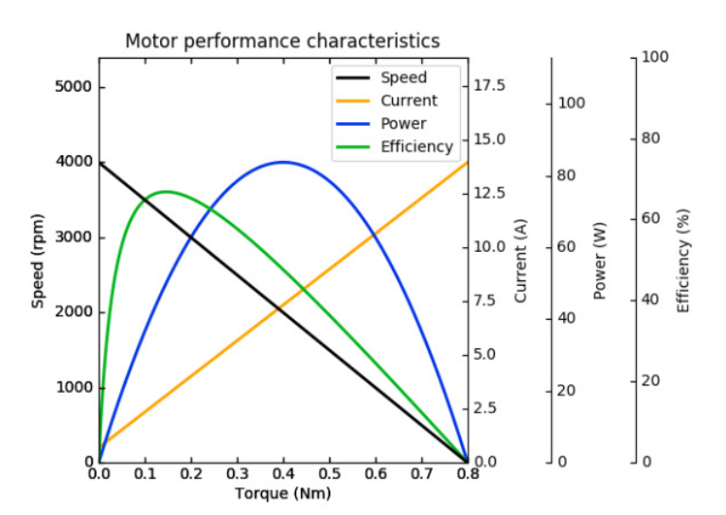

Battery Life:

- Capacity and Voltage: A higher-capacity battery can provide longer operational times, but the weight of the battery should be optimized to maintain the rover’s performance without compromising maneuverability.

- Battery Power Management: Power management systems can regulate the distribution of energy, ensuring the rover doesn’t overdraw from the battery and cause voltage drops that could affect performance

3. ELECTRICAL COMPONENTS

A. Power Supply:
1. LiPo Battery:

  - Role: This is the primary power source for your rover. It supplies the voltage and current necessary to drive the motors, motor driver, and RC receiver. LiPo (Lithium Polymer) batteries are preferred because they are lightweight, have high energy density, and provide a stable voltage output.

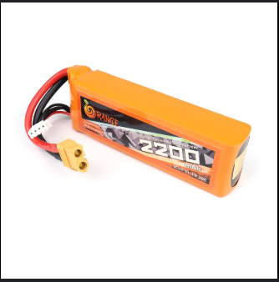

  - Battery Voltage Consideration: Using a 12V LiPo battery, this will be the main power supply. The voltage can vary, all components are rated for the battery’s output voltage.

2. Voltage Regulators (optional):

  - Role: Voltage regulators are used to step down the battery voltage to a lower value that is required by certain components, such as the RC receiver or microcontroller (if used). For example, while the motors might be running at 12V, the RC receiver might require only 5V.

  - Example: If the battery supplies 12V, you may need a 5V voltage regulator to provide the proper voltage for the receiver. Similarly, the motor driver (L298N) typically works with 5V or 12V, depending on how it's configured.

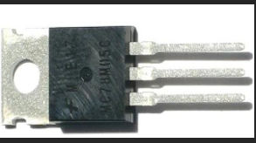

  - Types of Regulators: A buck converter is an efficient way to step down voltage for power-hungry components, while a linear regulator (like the LM7805) can be used for lower-power circuits.

B. Motor Control:

- L298N Motor Driver:
  - Role: The L298N is an H-Bridge motor driver that allows you to control the direction and speed of DC motors. An H-Bridge configuration lets you reverse the polarity of the voltage applied to a motor, which controls the direction of rotation (e.g., forward, reverse).
  - How it Works:
    - The L298N takes control signals from the RC receiver and provides power to the motors. When a forward signal is sent, it directs power to the motors to rotate in a forward direction; similarly, a reverse signal will reverse the motor direction.
    - It also allows for speed control by varying the voltage or pulse-width modulation (PWM) signal. By adjusting the duty cycle of the PWM signal, the speed of the motors can be controlled.
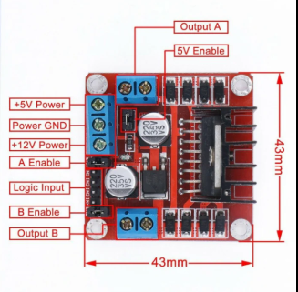

    - The L298N also ensures that the motors receive appropriate current, as DC motors typically draw more current than a microcontroller can provide directly.

- DC Motors:
  - Role: The DC motors receive power from the L298N and drive the wheels of the rover. They are responsible for generating the mechanical motion that propels the rover forward or backward and allows it to turn.
  - Control via PWM: The L298N adjusts the speed of the motors based on the PWM signal received from the RC receiver. This allows for precise control of the rover’s speed and movement.

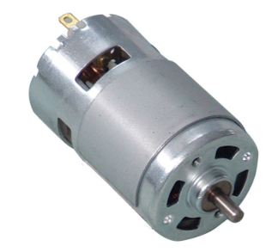

  - Motor Direction: The motor direction is controlled by switching the polarity of the voltage applied to the motor through the L298N’s H-Bridge circuit.

C. Control System:
- RC Receiver:
  - Role: The RC receiver is responsible for receiving the control signals sent from the RC transmitter (remote control). It decodes the signals and sends them to the motor driver (L298N), which then actuates the motors according to the commands.
  - Receiver Inputs: The RC receiver typically has multiple channels to receive control signals for different functions (e.g., one for forward/backward, one for left/right, one for speed control, etc.).

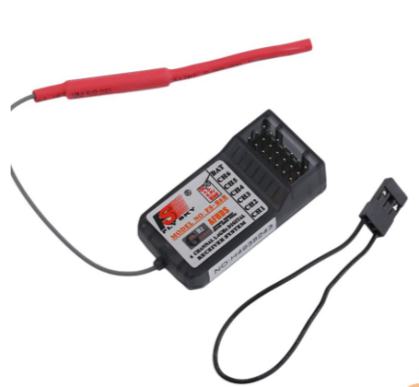

  - Control Signals to L298N: Once the receiver decodes the signals, it sends them to the appropriate input pins on the L298N to control motor movement (e.g., signals to rotate left, right, move forward, or reverse).

- Transmitter:

  - Role: The RC transmitter is the remote control device that sends radio signals to the receiver. It typically has joysticks or buttons that allow the user to send directional commands to the rover.

  - Operation: The transmitter sends the control commands (e.g., move forward, turn left) on a certain frequency, which is then received by the RC receiver on the rover. The receiver decodes these commands and triggers the appropriate action on the motor driver.

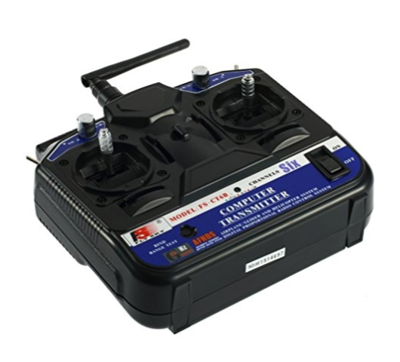

4. CIRCUIT DIAGRAM

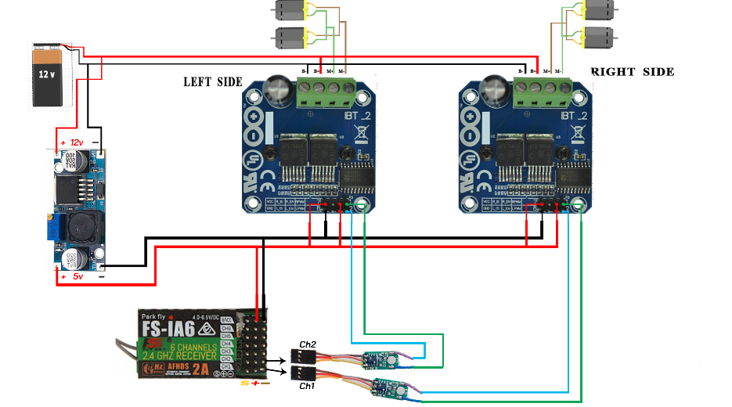

Circuit Connections:
1. Power Distribution:
- LiPo Battery Connection:
  - Connect the positive terminal of the LiPo battery to the VCC input of both the L298N Motor Driver and the RC Receiver.
  - This ensures that both the motor driver and the receiver get power to operate.
  - Connect the ground terminal of the LiPo battery to the GND of both the motor driver and the receiver. The ground (GND) connection is essential for completing the circuit and ensuring that signals between the components are referenced correctly.
2. Motor Driver to Motors:
- L298N Output Pins:
  - The L298N motor driver has output terminals (OUT1, OUT2 for one motor and OUT3, OUT4 for another) that connect directly to the DC motors. These output pins provide the voltage required to turn the motors in the desired direction.
  - When the L298N receives a forward command from the RC receiver, it supplies power to the motors in one direction. If it receives a reverse command, it reverses the polarity of the output voltage to reverse the motor direction.
3. Receiver to Motor Driver:
- Receiver to Motor Driver Pins:
  - The RC Receiver outputs control signals that need to be sent to the L298N Motor Driver. Typically, this involves using multiple signal lines to control the direction and speed of each motor.
  - The control pins on the L298N (IN1, IN2, IN3, IN4) correspond to the signals coming from the receiver. For example, the RC receiver might send a signal to IN1 and IN2 to control the direction of one motor, while IN3 and IN4 control the second motor.
  - For speed control, the RC receiver may also send PWM signals (using PWM pins) to control the duty cycle, adjusting the speed of the motors.
4. Transmitter to Receiver:
- Pairing:
  - The transmitter and receiver must be correctly paired to ensure they communicate on the same frequency. This is usually handled during setup, where the transmitter sends a signal that the receiver recognizes.
  - The transmitter will send specific commands, such as "move forward," "turn left," or "speed up," which are then decoded by the receiver and sent to the motor driver to execute the actions.

Summary of Circuit Functionality:
- Transmitter → Receiver: The user sends commands (forward, backward, left, right) through the RC transmitter.
- Receiver → Motor Driver: The RC receiver decodes the signals and passes them to the motor driver (L298N).
- Motor Driver → Motors: The L298N motor driver interprets the control signals and powers the motors accordingly, adjusting direction and speed.
- Power Supply: The LiPo battery powers the motor driver, receiver, and other components, with optional voltage regulators stepping down voltage where necessary.

PHOTOS OF ROVER:

- FRONT :-

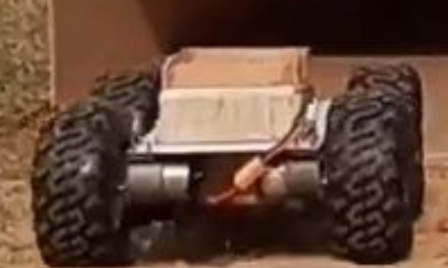

- SIDE(RIGHT , LEFT,FRONT) :-

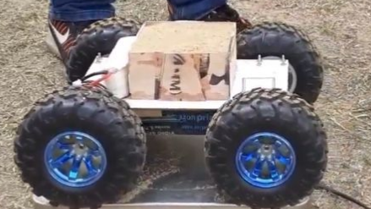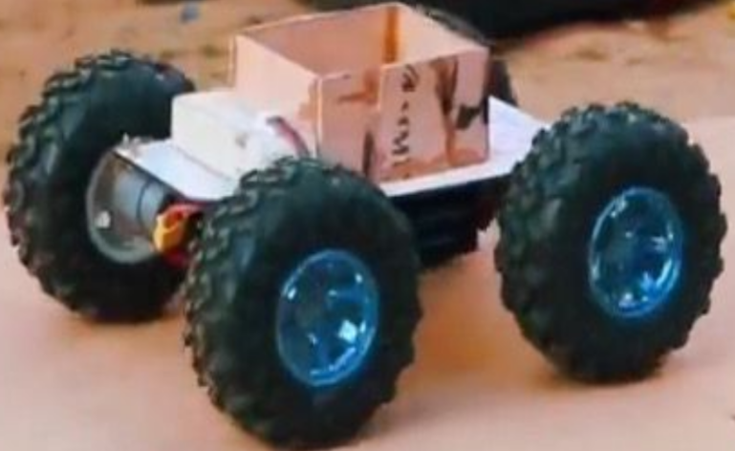

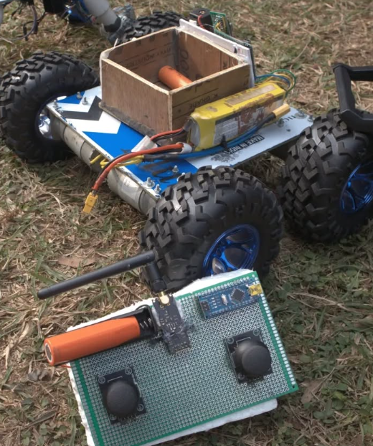

Rover Components with Budget :

Component | Model Name / Description | Quantity | Price (₹)
Wooden sheet | 10cm*10cm*5cm | 1 | 200
Off-Road Wheels |  | 4 | 250
DC Motors (High Torque) | 5-10 kg/cm | 4 | 2800
Motor Driver | L298N | 2 | 300
Battery | LiPo(7.4v or 11.1v) | 1 | [varies]
RC Controller and Receiver | 2.4Gz | 1 | 2100
Fasteners and Adhesives |  | various | 200
Bearings |  | various | 500
Tools (Drill, etc.) |  | various | [varies]
Miscellaneous |  | various | 500
Total Cost |  |  | ₹ 7950
Note: total price is approximate and may vary.
























